**National University of Computer and Emerging Sciences**



**Laboratory Tasks 12**

*for*

# Web Engineering

*Instructor: Saqib Ameer*

*Email: saqib.ameer@nu.edu.pk*

# Spring 2024

**FAST School of Computer Science**

ImageURl:- https://www.nu.edu.pk/Content/images/Slider/adm-sp-2022-2.jpg

Note:- Use the useEffect() Hook when you display the record

Required dependencies for backend

1. Express ii) cors iii) mongoose iv) dotenv

Required dependencies for frontend

1. React-router-dom ii) axios

Web Engineering Lab Task Consider as a Quiz

You need to make as system of Daira event manage using mern stack project

1. In this task you need to make two pages one for add new event
2. And second page is display all events in the form of card view

Schema: Event_id , eventname , eventtype , imageUrl , eventplace , eventtime

Name of the schema is FASTNUEvents

Description:

For implement this make two components with name AddEvent and DisplayEvent

Call these Component in the main file App.js

One component with name navbar is must for every page

In backend make two APIS for add and display

It is upto you how you desing these pages but for simple designing consider the page given below.

**Display Page**

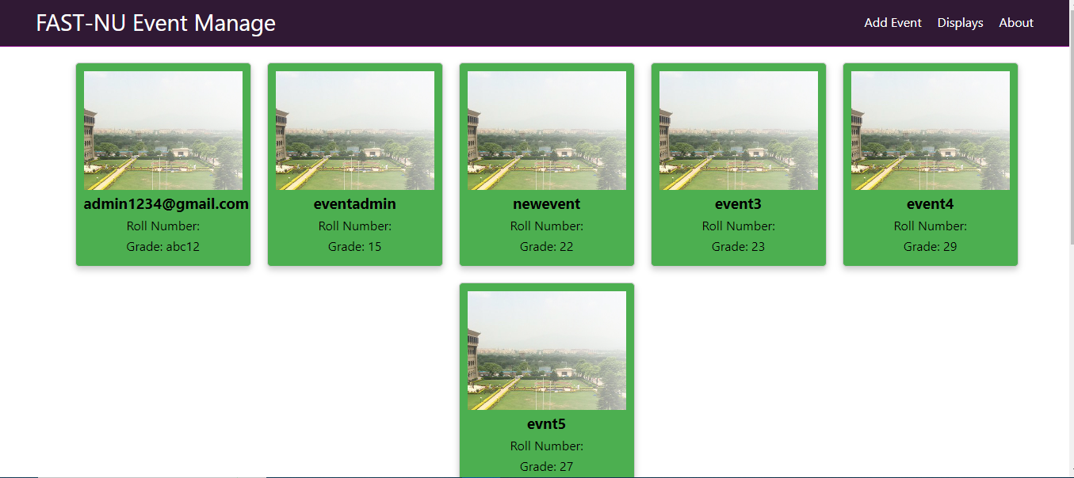

**AddEvent Page**

